IOT BASED AIR QUALITY MONITORING

A project report submitted in partial fulfillment of the

requirements for the degree of B.E Electronics And Communication Engineering

By,

**S.Susi(513221106327)**

Under the supervision of HOD&proffessor

Department of B.E Electronics And Communication Engineering

PHASE-4:DEVELOPMENT-2 OF AIR QUALITY MONITORING

Topics:

* ***Introduction of Air Quality Monitoring Systems***
* ***Relevant Survey***
* ***Proposed Method: IoT-Based Air Quality Monitoring System***
* ***Conclusions***

**Introduction of Air Quality Monitoring Systems:**

* Air quality monitoring refers to continuous measurement of specific air pollutants also known as “criteria air pollutants”.  Obtained air pollution data together with natural background/trace gas monitoring and stationary source emission monitoring helps to define what kind of air pollution people are exposed to.
* Air pollution monitoring data is essential for air pollution assessment, countermeasures and environment pollution policies by local and national authorities, private and public companies, and national organizations.
* HORIBA offers cutomer oriented tailor-made system solutions with its state-of-the-art analytical technologies and more than 50 years experience in ambient air market.
* As your true partner in environmental preservation, we deliver air quality monitoring, indoor air quality monitoring , clean room airborne molecular contamination monitoring , quality control and stationary emission monitoring by diluted stack gas monitoring.
* **Relevant Survey** :

**Steps involved in Air Testing Service:**

* Collecting air samples from the site
* Battery operated instruments for real-time measurements of Temperature, Humidity, Wind direction, Wind speed, PM2.5, PM10, CO, CO2, NOx, etc.
* Monitoring human exposure to harmful pollutants
* Detection & measurement of harmful gases in air from the collected sample
* Provide solutions to further improve Air quality in Companies
* Air quality testing and monitoring are done in areas where pollution problem exists and it is expected e.g. Companies Premises, Industrial area, traffic intersection.
* It is good to conduct Air Pollution Testing program in order to get annual average sampling as pollutants behave in each season differently. It recommended that in a year 104 Air emissions monitoring of 24 hrs. i.e. twice a week.

**Proposed Method: IoT-Based Air Quality Monitoring System**

In this research, nodemcu esp8266 is used as the micro controller. This board has Wi-Fi module that acts as the internet connector and information accessing for the air quality[3]. This is the reason why this board is chosen as some of tools for this research, besides the price of this board is very cheap as well. This is the input pin and picture of nodemcu esp8266: 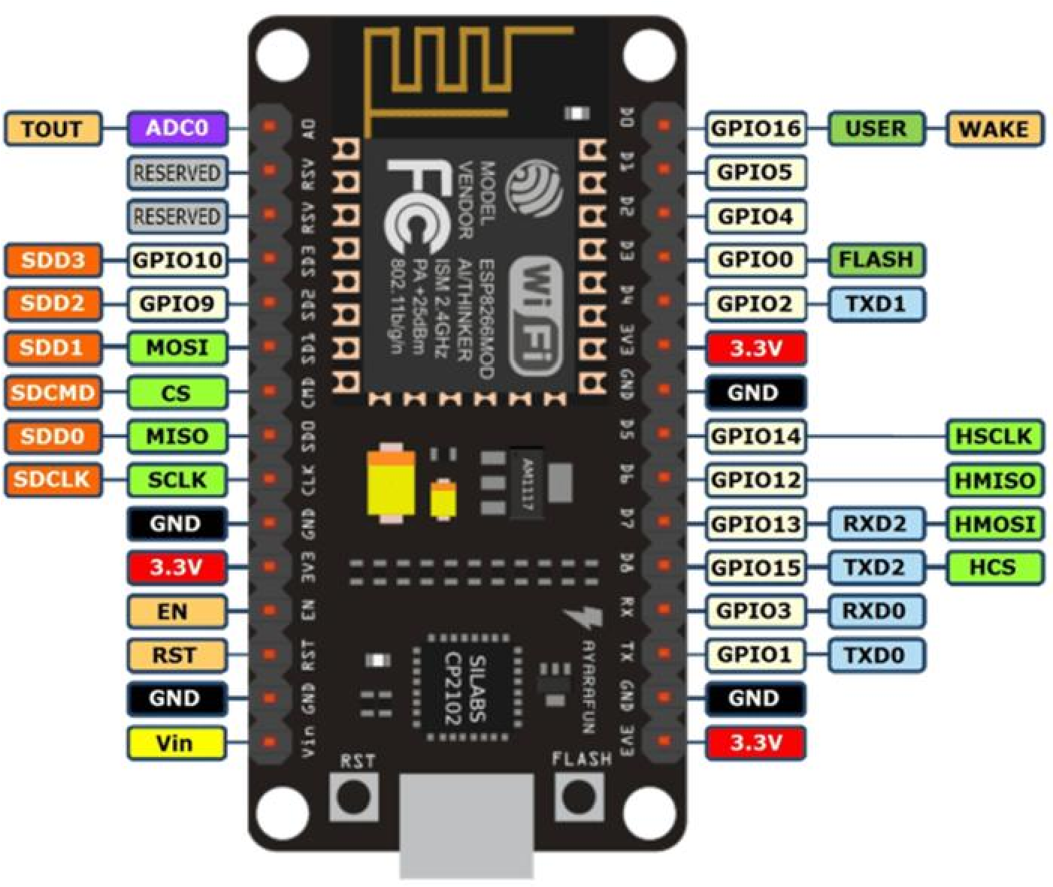

1. Nodemcu ESP8266
2. MQ2 gas sensor
3. MQ9 gas sensor
4. Analog Multiplexer 4051 (CD4051BE)
5. 1.3 inches OLED monitor SSD1306
6. 180ohm resistor x2 and 330 ohm resistor x2
7. Adapter 5v
8. ZH03A Laser Dust Sensor

* MQ2 sensor module is used for gas leakage detection (home and industry). It is suitable for detecting H2, LPG, CH4, CO, Alcohol, Smoke or Propane. Due to the high sensitivity and fast response time of it. But, in this design, we used MQ2 sensor for smoke situation. This sensor has four outputs, namely, Vcc, ground, D0, and A0. Not all outputs will be connected to nodemcu. However, only D0 that is not connected to nodemcu because this sensor only can choose one output A0 or D0.

1. 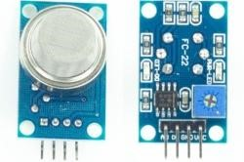

**Figure 2.** MQ2 sensor

1. The same features with the MQ2 sensor, MQ9 sensor is sensitive and also fast response time. This sensor is suitable for detecting H2, LPG, CH4, CO, Alcohol, Smoke or Propane. The utilization r is for detecting the Carbon Monoxide (CO). The shape of this MQ9 is the same as the sensor MQ2, but it is bigger than MQ2[4]. For the output of this sensor, it is same with MQ2 output.

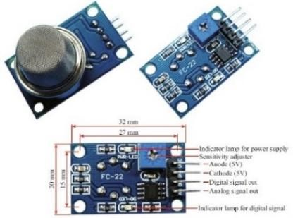

## Result and Disscusion:

Last step after wiring all parts to PCB board is covering all parts with the box. All sensors must be contacted to the air directly. The box needs to drill until the sensors and LCD fit with the box. And then, the all parts seem good looking with the box. The dimension of box is 18 cm x 11 cm x 6 cm. The Figure 9 shows the front and rear view of the box. It can be seen, the box is not too small nor too big as well, so the box is easy to carry anywhere.

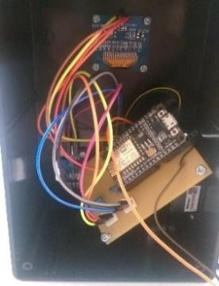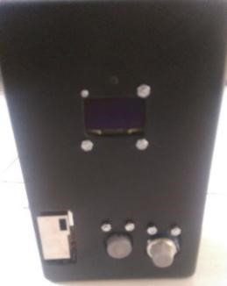

**Figure 9.** Box of air quality monitoring

Next, we will illustrate the result of the measurement from sensors. The data is taken from the measurement of a cigarette:

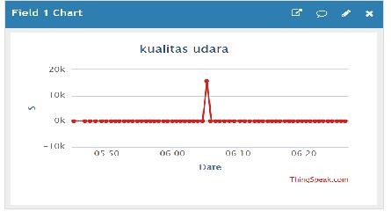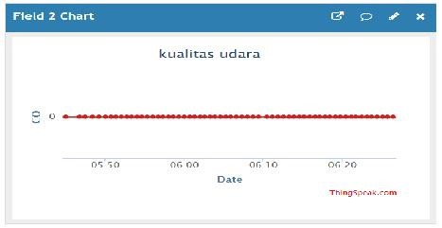

**Figure 10**. Results of smoke content readings **Figure 11**. Carbon monoxide reading results

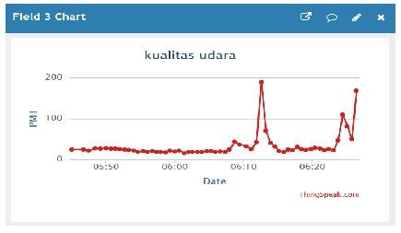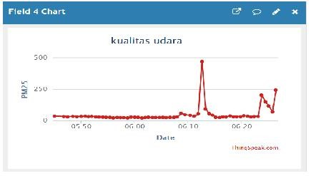

**Figure 12.** Results of PM1 Reading **Figure 13.** Results of PM2.5 Reading

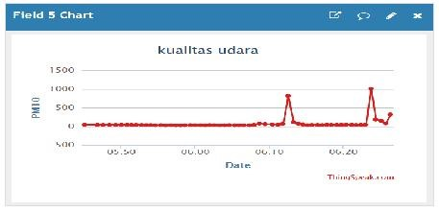

**Figure 14.** Results of PM10 Reading

The results show that if the red line is upward, the particle level of pollution is higher and dangerous. At level of 0-50 ppm, healthy air falls into the healthy category, while in the range 50 – 100 ppm is categorized medium air (no effect on health). The range of 100-200 ppm, air is not healthy, 200-300 ppm is very unhealthy, while 300 upwards is said to be very dangerous [8]. As shown in figure 10, the smoke point indicates that the smoke level is above 10k, indicating that the ambient air condition is very dangerous.

## Conclusion:

An air quality detector is very important because nowadays air pollution is easy to find. For the air pollution which cannot be easy detected by human, it requires a device as a reader of the air quality. By this research, we can avoid air pollution through monitoring the air quality regularly.